HANOI UNIVERSITY OF SCIENCE AND TECHNOLOGY
SCHOOL OF INFORMATION AND COMMUNICATION TECHNOLOGY

GRADUATION RESEARCH REPORT (GR1)
Topic: Design and Development of a Web-Based Fitness Platform for Beginner Gym Users
Project Code Name: FiFB (Fitness for Beginners)

NGÔ ĐỨC HUY
Huy.nd235946@sis.hust.edu.vn
Program: Global ICT

Supervisor: Professor Cao Tuan Dung
Department:
School: School of Information and Communications Technology

HANOI, 07/2026
Table of Contents
Chapter 1 – Introduction 4
1.1 Scientific and Technological Context 4
1.2 Problem Significance and Motivation 5
1.3 Objectives and Scope 5
1.4 Research Tasks 6
1.5 Planned Roadmap: GR1 → GR2 7
Chapter 2 – Related Work and Practical Survey 7
2.1 Overview of Existing Fitness Platforms 7
2.2 Comparative Analysis 7
2.3 Derived Requirements for the Foundation Demo 8
2.4 GR1 Feature Scope and Exclusions 9
Chapter 3 – Theoretical Foundations and Technology Stack 9
3.1 Client–Server Architecture and RESTful APIs 9
3.2 Authentication and Authorization 10
3.3 Role-Based Access Control and Actor Separation 11
3.4 Relational Database Design 11
3.5 GR1 Scope Boundary and Demo Focus 11
3.6 Technology and Framework Selection 12
Chapter 4 – FiFB Product 13
4.1 Functional Requirements 13
4.2 Non-Functional Requirements 15
4.3 System Architecture 15
4.4 Database Design 16
4.5 Backend Implementation 18
4.5.1 API Endpoints 18
4.5.2 Middleware Pipeline 18
4.5.3 Exercise and Equipment Data Management 19
4.5.4 Core Role and Authorization Flow 19
4.6 Frontend Implementation 19
4.6.1 Application Structure 19
4.6.2 Routing and Access Control 20
4.6.3 HTTP Client and Token Management 20
4.6.4 Role State Management 20
4.6.5 Shared Components Used in the Core Demo 20
4.7 Role-Based Demo Workflows 21
4.7.1 Core Actions by Role 21
4.7.2 User Exercise Lookup Flow 21
4.8 Scope Boundary for Additional Implementations 21
4.8.1 Implemented Extensions Not Evaluated in GR1 21
4.8.2 Reason for Exclusion 22
4.8.3 Future Use of Existing Code 22
Chapter 5 – Results and Evaluation 22
5.1 Completion Status 22
5.2 Demonstration and Outputs 23
5.3 Functional Evaluation 26
5.3.1 Authentication and Role Access 26
5.3.2 User Management 27
5.3.3 Exercise and Equipment Management 27
5.3.4 User Exercise Lookup 27
5.3.5 Scope Assessment 27
5.4 Limitations 27
5.5 Development Plan for GR2 28
References 28
Appendices 29

LIST OF ABBREVIATIONS
Abbreviation | Full Term
API | Application Programming Interface
CORS | Cross-Origin Resource Sharing
CRUD | Create, Read, Update, Delete
CSS | Cascading Style Sheets
ER | Entity–Relationship
GR1 | Graduation Research 1
GR2 | Graduation Research 2
HTML | HyperText Markup Language
HTTP | HyperText Transfer Protocol
JWT | JSON Web Token
MVP | Minimum Viable Product
OTP | One-Time Password
REST | Representational State Transfer
SPA | Single-Page Application
SQL | Structured Query Language
UI/UX | User Interface / User Experience
UUID | Universally Unique Identifier

Chapter 1 – Introduction

1.1 Scientific and Technological Context
Digital fitness platforms can help beginner gym users access consistent exercise information through a centralized web application. For a GR1 project, the main academic value is not the number of advanced features, but the ability to translate a practical problem into clear requirements, user roles, a relational database design, and a working full-stack demonstration.
FiFB is therefore developed as a client–server web system using React for the frontend, Express.js for the backend, and PostgreSQL for persistent data. These technologies are sufficient to demonstrate authentication, role-based access, user management, exercise management, equipment classification, and exercise lookup without requiring advanced real-time or AI components.
The project applies core software engineering knowledge from requirements analysis, system architecture, database design, API development, frontend development, and basic testing within the Information Technology curriculum at HUST.

1.2 Problem Significance and Motivation
Beginner gym users and system administrators face several basic problems that motivate the FiFB foundation demo:
- Information fragmentation: Exercise names, instructions, target muscles, and required equipment are distributed across many sources, making reliable lookup difficult for beginners.
- Difficulty selecting suitable exercises: Beginners need a simple way to search and filter exercises by body part, muscle group, and equipment or machine category.
- Lack of centralized management: A web platform needs clearly separated Admin, Trainer, and User roles so that accounts and exercise data can be maintained consistently.
FiFB addresses these core problems by providing a centralized exercise library, role-based interfaces, user-account administration, exercise-content administration, equipment taxonomy management, and a searchable exercise interface for users.

1.3 Objectives and Scope
Objectives
The primary objective of GR1 is to design and build a foundation demo of the FiFB web platform with the following capabilities:
- Allow users to browse, search, filter, and view detailed exercise information, including body parts, target muscles, and required equipment.
- Provide secure login and role-based access for the three system roles: User, Trainer, and Admin.
- Allow Admin to list users, inspect user information, and change account status.
- Allow Admin to create, update, review, and deactivate exercise records.
- Allow Admin to list and add exercise equipment or machine categories, and associate them with exercises.
- Allow Trainer to maintain a basic trainer profile and submit exercise content for Admin review.
A secondary objective is to organize the code into a modular architecture that can be extended later, while keeping the GR1 evaluation focused on the required foundation functions.
Scope
The evaluated scope of GR1 includes:
- Authentication and authorization based on JWT.
- Role definition and access control for User, Trainer, and Admin.
- Relational database design for users, trainer profiles, exercises, body parts, muscles, and equipment categories.
- Basic Trainer profile management and exercise submission for review.
- Admin user management, including list, filter, detail, and status update operations.
- Admin exercise management, including creation, update, review, and deactivation.
- Equipment or machine-category management through the exercise taxonomy module.
- User exercise lookup through keyword search, filters, pagination, and exercise-detail pages.
Although the repository contains additional implemented modules, the following are outside the evaluated GR1 scope of this report: favorite exercises, workout plans and workout sessions, statistics and progression, trainer certificates and connections, reviews, chat, notifications, Redis caching, deployment automation, online payment, marketplace functions, and AI features.

1.4 Research Tasks
The following tasks were defined for the focused GR1 scope:
- Problem and requirement analysis: Identify the needs of beginner users and define the responsibilities of User, Trainer, and Admin.
- System design: Design the client–server architecture, role-based access model, database schema, API groups, and primary user interfaces.
- Database design: Model users, trainer profiles, exercises, equipment, body parts, muscles, and their many-to-many relationships.
- Backend development: Implement the Express.js modules for authentication, users, trainers, exercises, exercise taxonomy, and core Admin operations.
- Frontend development: Implement login, role-protected routing, Admin user and exercise pages, Trainer submission pages, and User exercise lookup pages.
- Verification: Manually test the main role flows and use existing linting and unit-test support to check the codebase.

1.5 Planned Roadmap: GR1 → GR2
Phase | Period | Key Deliverables
GR1 | 2025.2 | Foundation demo: role model, database design, login, user management, exercise management, equipment taxonomy, and User exercise lookup.
GR2 | 2026.1 | Complete physical machine inventory management, improve Trainer workflows, expand testing and UI/UX, and selectively integrate advanced features.
This roadmap deliberately separates the foundation requirements from optional extensions. GR1 demonstrates that the core architecture, database, and role-based functions work; GR2 can then extend the same modules without redefining the entire system.

Chapter 2 – Related Work and Practical Survey

2.1 Overview of Existing Fitness Platforms
Three representative platforms and data sources were reviewed to derive requirements for the FiFB foundation demo:
- Jefit (jefit.com): A fitness application with a large exercise library and filtering functions. It provides a useful reference for how exercise information can be presented to users.
- Trainerize (trainerize.com): A trainer-oriented platform that demonstrates the value of separating trainer and client responsibilities, although its scope is broader than the FiFB GR1 demo.
- ExerciseDB (exercisedb.io): An exercise-data API containing GIF demonstrations, target muscles, body parts, and equipment information. It is used as a reference data source rather than as a complete end-user application.

2.2 Comparative Analysis
[Bảng 2.1: Comparison of Existing Fitness Platforms]
Feature | Jefit | Hevy | Trainerize | ExerciseDB API | FiFB (GR1)
Exercise Library with GIF | ✓ | Partial | ✓ | ✓ (API only) | ✓
Taxonomy-based Filtering | Partial | ✗ | Partial | ✓ | ✓
Role-based access control | Partial | Partial | ✓ | ✗ | ✓
User account management | Partial | Partial | ✓ | ✗ | ✓
Exercise content management | Partial | Partial | ✓ | API only | ✓
Equipment category management | Partial | Partial | Partial | ✓ | ✓
Trainer exercise contribution | ✗ | ✗ | ✓ | ✗ | ✓
Admin Moderation | ✗ | ✗ | ✓ | ✗ | ✓
Open / Web-based | Partial | Partial | ✓ | API only | ✓
Beginner-focused | Partial | ✗ | ✗ | ✗ | ✓

The comparison leads to three findings relevant to GR1:
- Exercise libraries are useful only when users can search and filter structured data such as body parts, muscles, and equipment.
- Trainer-oriented systems show the importance of role separation, but GR1 only needs a basic Trainer role rather than a complete trainer–client ecosystem.
- ExerciseDB is suitable as an initial data source, while FiFB must still provide its own database, management interface, authorization rules, and user-facing web pages.

2.3 Derived Requirements for the Foundation Demo
Based on the survey and the GR1 assignment, the following requirements were selected:
Core functional requirements:
- A standardized exercise library with name, GIF, instructions, body-part, muscle, and equipment metadata.
- Keyword search, taxonomy-based filtering, pagination, and exercise-detail viewing for User.
- Login and role-based authorization for User, Trainer, and Admin.
- Admin functions for listing users and changing account status.
- Admin functions for creating, updating, reviewing, and deactivating exercises.
- Equipment or machine-category management and exercise–equipment association.
- Basic Trainer profile management and exercise submission for Admin review.
- A relational database schema that preserves referential integrity between users, exercises, and taxonomy data.
- A clear separation between the core GR1 requirements and optional extensions already present in the repository.
Quality requirements:
- Reasonable response time for standard login, CRUD, search, and filtering operations in a demonstration environment.
- Role-based access control so that each role can only use permitted functions.
- Foreign keys, status constraints, and normalized many-to-many mappings for data integrity.
- A modular backend structure that separates routes, controllers, services, repositories, and validation.
- Secure password storage and token-based authentication.

2.4 GR1 Feature Scope and Exclusions
The GR1 report evaluates only the foundation functions required by the assignment: system design, role definition, database design, login, user management, exercise management, equipment taxonomy management, and User exercise lookup. This focused scope is sufficient to demonstrate a working platform foundation.
Additional implemented code for workout tracking, trainer connections, certificates, reviews, chat, notifications, caching, CI/CD, deployment, and future AI functions is not used as evidence of GR1 completion and is not described in detail.

Chapter 3 – Theoretical Foundations and Technology Stack

3.1 Client–Server Architecture and RESTful APIs
FiFB follows the client–server architectural pattern, where the frontend (client) and backend (server) are developed as separate applications communicating over HTTP.
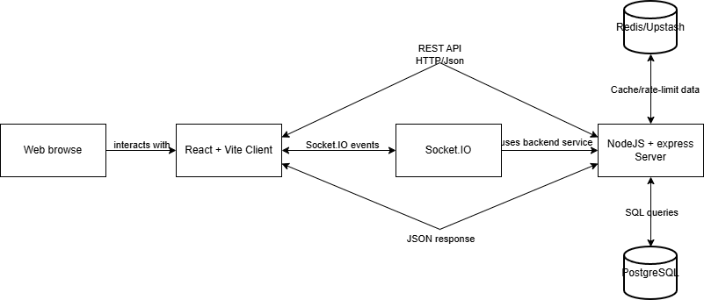
[Figure 3.1: Client–Server Architecture Overview. The image reflects the extended repository; the evaluated GR1 path is React Client → Express API → PostgreSQL.]
The backend exposes a RESTful API following standard HTTP semantics:
- Resource-based URLs, for example `/api/exercises`, `/api/users`, and `/api/exercise-taxonomy/equipments`.
- Standard HTTP methods: `GET` for retrieval, `POST` for creation, `PATCH` for partial updates, `DELETE` for removal.
- Consistent response format: All responses follow a standardized JSON envelope: `{ "success": true/false, "data": {...}, "message": "..." }`.
- Pagination: List endpoints return paginated results with `items`, `page`, `limit`, `total`, and `totalPages` fields.
- Error format: Errors include machine-readable `code`, human-readable `message`, and optional `details` for validation errors.
The separation of concerns between client and server allows independent scaling, testing, and potential replacement of either tier.

3.2 Authentication and Authorization
FiFB uses JWT-based authentication so that the backend can identify the current account and enforce role-specific permissions.
The core design decisions are:
- After login, the backend issues an access token containing the user identifier, role, and account status. The frontend sends this token in the `Authorization: Bearer` header for protected requests.
- A refresh-token mechanism supports session continuity; password hashes are stored with bcrypt rather than as plain text.
- Password hashing: bcrypt is used to protect stored passwords.
- Account verification: registration can place accounts in a pending state until email verification is completed.
Authorization is enforced at three levels:
- Middleware layer: `authenticate` validates the token, while role middleware checks whether the request is made by User, Trainer, or Admin.
- Service layer: business rules verify that only permitted roles can manage users, exercises, trainer data, or taxonomy data.
- Database layer: foreign keys, unique constraints, and valid status values protect data consistency.

3.3 Role-Based Access Control and Actor Separation
Role-based access control is central to the GR1 demo because the same web platform serves three actors with different responsibilities:
- User: logs in, manages a basic profile, searches and filters exercises, and views exercise details.
- Trainer: has User-level exercise access, manages a trainer profile, and can submit new exercise content for review.
Admin: manages user status, exercise records, submitted exercises, and exercise taxonomy such as equipment, body parts, and muscles.

3.4 Relational Database Design
PostgreSQL is used because the GR1 domain contains strongly related data: accounts have roles, exercises are associated with multiple body parts, equipment categories, and muscles, and Trainer profiles extend user accounts.
Key database design principles applied in FiFB:
- Normalization: body parts, equipment, and muscles are stored separately from exercises and connected by junction tables, reducing duplication and supporting consistent filters.
- Status-based lifecycle: users and exercises use status values so records can be locked, disabled, inactive, or rejected without immediately losing historical data.
- UUID primary keys: database records use UUID identifiers to avoid predictable sequential identifiers and simplify relationships across modules.
- Constraints: role, status, and relationship constraints prevent invalid data from being stored.
- JSONB instructions: ordered exercise instruction steps can be stored without creating an unnecessarily complex table structure.
- Indexes: frequently queried fields such as user email, user status, exercise status, exercise name, and taxonomy identifiers are indexed for lookup operations.

3.5 GR1 Scope Boundary and Demo Focus
A clear scope boundary is necessary because the repository has grown beyond the minimum GR1 assignment.
- The core evaluation follows only the path required to demonstrate the platform foundation: authentication, role checking, user administration, exercise administration, equipment taxonomy, and User exercise lookup.
- Modules for favorites, workout plans, workout sessions, trainer connections, reviews, chat, notifications, caching, and deployment remain in the source code as extensions.
- These extensions are intentionally excluded from the detailed report so that they do not obscure the required analysis and do not create the impression that GR1 success depends on advanced features.
- This approach also makes the limitations of the current equipment implementation explicit: it is an exercise-equipment taxonomy, not yet a full physical machine inventory system.

3.6 Technology and Framework Selection
[Bảng 3.1: Technology Stack Summary]
Layer | Technology | Purpose
Frontend | React | UI component library
 | Vite | Build tool and dev server
 | React Router DOM | Client-side routing
 | Axios | HTTP client
 | Tailwind CSS | Utility-first CSS framework
 | Lucide React | Icon library
 | React Hook Form | Form state management
Backend | Node.js | JavaScript runtime
 | Express.js | HTTP framework
 | PostgreSQL | Relational database
 | jsonwebtoken | JWT creation and verification
 | bcryptjs | Password hashing
 | Zod | Schema validation
 | Helmet | HTTP security headers
 | pg (node-postgres) | PostgreSQL driver
 | ESLint | Code linting
 | Prettier | Code formatting
 | Jest | Unit testing
 | Supertest | HTTP integration testing
 | Nodemon | Development auto-restart

Rationale for the technologies used in the core demo:
- React + Vite supports reusable role-based pages and rapid development of the login, management, and exercise lookup interfaces.
- Express.js provides a lightweight REST API structure that maps naturally to authentication, users, exercises, taxonomy, and Admin modules.
- PostgreSQL is appropriate because users, roles, exercises, equipment, body parts, and muscles require relational integrity and many-to-many mappings.
- Zod validates request parameters and bodies before they reach the service layer, reducing inconsistent data and repeated manual checks.

Chapter 4 – FiFB Product

4.1 Functional Requirements
The system defines three stored roles: User, Trainer, and Admin. An unauthenticated visitor is not a database role and can only use public exercise pages and authentication pages. The table below lists only the functions evaluated in GR1.
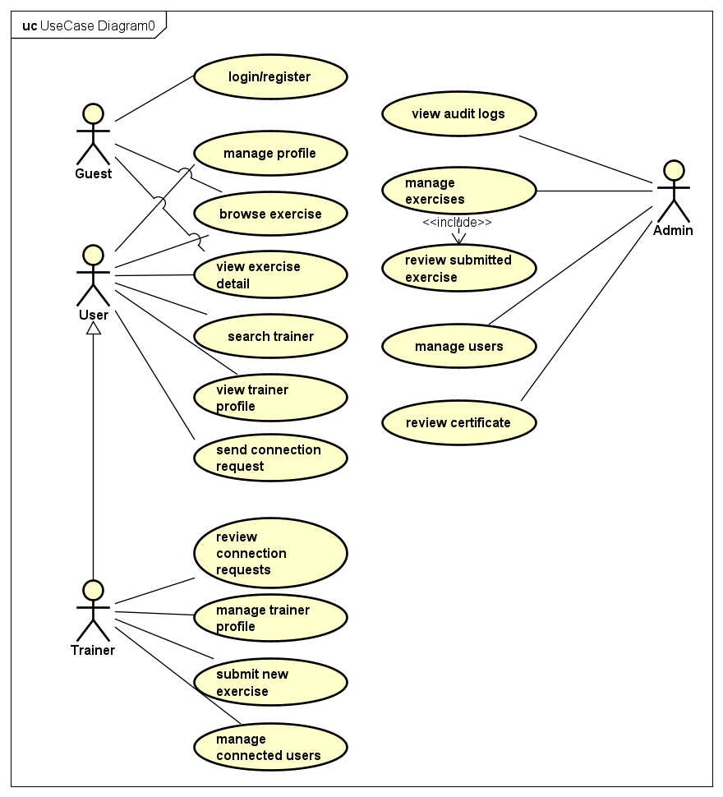
[Figure 4.1: Use Case Diagram]
[Bảng 4.1: Functional Requirements by Actor]
Unauthenticated visitor (not a stored system role)
ID | Requirement | Description
G-01 | Browse exercises | View active exercises with GIF, instructions, and taxonomy.
G-02 | Filter exercises | Filter by body part, equipment, target muscle, secondary muscle, and keyword.
G-03 | View exercise detail | View full exercise detail including all taxonomy associations.
G-04 | Register account | Register as User or Trainer and create an account for later login.
G-05 | Login / Logout | Authenticate with email and password and end the current session.

User (Authenticated, role = `user`)
ID | Requirement | Description
U-01 | Manage profile | View and update personal profile fields.
U-02 | Search exercises | Search active exercises by keyword.
U-03 | Filter exercises | Filter by body part, equipment, target muscle, or secondary muscle.
U-04 | View exercise detail | View GIF, instructions, body-part, muscle, and equipment information.
U-05 | Use User interface | Access only routes and actions permitted for the User role.

Trainer (Authenticated, role = `trainer`)
ID | Requirement | Description
T-01 | Manage trainer profile | Create/update bio, specialization, and years of experience.
T-02 | Browse exercises | Search, filter, and view the shared exercise library.
T-03 | Submit exercise | Submit new exercise information with pending status for Admin review.
T-04 | Use Trainer interface | Access trainer-only profile and exercise-submission routes.
In the focused demo, the Trainer role does not manage users or exercise taxonomy.

Admin (Authenticated, role = `admin`)
ID | Requirement | Description
A-01 | Manage users | List, filter, inspect, lock, unlock, or disable user accounts.
A-02 | Review exercises | Approve, reject, or deactivate trainer-submitted exercises.
A-03 | Create exercises | Create exercise records directly as Admin.
A-04 | Update exercises | Edit exercise information and taxonomy mappings.
A-05 | Manage equipment categories | List and add equipment or machine categories used to classify exercises.
A-06 | Manage other taxonomy | List and add body-part and muscle categories.
A-07 | Use Admin interface | Access only routes protected for the Admin role.

4.2 Non-Functional Requirements
Category | Requirement
Performance | Standard login, CRUD, list, search, and filtering operations should respond within an acceptable time for a classroom demonstration; list endpoints use pagination.
Security | Passwords are hashed with bcrypt; JWT identifies the current role; protected routes enforce User, Trainer, or Admin permissions; CORS and validation are applied.
Data integrity | UUID primary keys, foreign keys, unique constraints, valid role/status values, and normalized exercise-taxonomy relationships.
Reliability | Centralized backend error handling and frontend error states prevent a failed request from breaking the entire demonstration flow.
Maintainability | The backend separates routes, controllers, services, repositories, and validation; the frontend separates API clients, routes, layouts, and role pages.
Usability | Role-specific navigation and clear search/filter controls allow each actor to complete the required demo tasks with minimal steps.

4.3 System Architecture
The evaluated GR1 architecture contains three main parts:
Client (React + Vite)
│
└── REST / JWT ──→ Express API Server
│
└── SQL queries ──→ PostgreSQL Database
The backend follows a layered modular pattern:
Routes (Express Router)
└── Controller (request parsing and response formatting)
└── Service (business rules and authorization)
└── Repository (SQL queries)
└── PostgreSQL
Each core business domain is organized with the following responsibilities:
- `.routes.js` — Express route definitions with middleware composition.
- `.controller.js` — Thin controllers delegating to services.
- `.service.js` — Business logic and validation.
- `.repository.js` — SQL queries and database interaction.
- `.validation.js` — Zod schemas for request validation.
The modules directly evaluated in this report are `auth`, `users`, `trainers`, `exercises`, `exerciseTaxonomy`, and `admin`. Other repository modules are implemented extensions and are outside the focused GR1 evaluation.

4.4 Database Design
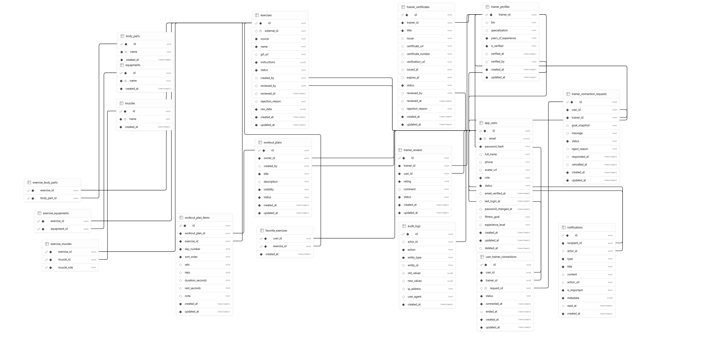
The ERD image shows the complete repository schema. The discussion below intentionally focuses on the tables needed for the GR1 foundation requirements.
[Figure 4.3: Entity–Relationship Diagram]
The complete schema contains additional extension tables, but the core GR1 data model is organized into the following groups:
Core Group 1: Users, Roles, and Authentication
Table | Description
`app_users` | Stores email, password hash, role, account status, and basic profile data for login and Admin user management.

Core Group 2: Trainer Role Extension
Table | Description
`trainer_profiles` | A one-to-one extension of `app_users` for the Trainer role, containing basic biography, specialization, and experience information.

Core Group 3: Exercises, Equipment, and Classification
Table | Description
`exercises` | Stores exercise name, GIF URL, instruction steps, source, lifecycle status, and imported source data. Admin can create/update records and review Trainer submissions.
`body_parts` | Taxonomy: body parts (e.g., chest, back, legs).
`equipments` | Stores equipment or machine categories used to classify exercises, such as barbell, dumbbell, cable, or machine.
`muscles` | Taxonomy: muscle groups (e.g., pectorals, biceps, quadriceps).
`exercise_body_parts` | Many-to-many: exercises ↔ body parts.
`exercise_equipments` | Many-to-many: exercises ↔ equipment.
`exercise_muscles` | Many-to-many with role: exercises ↔ muscles (target or secondary).

Supporting Group: Administrative Traceability
Table | Description
`audit_logs` | Records sensitive Admin changes such as user-status and exercise-status updates. It supports traceability but is not a separate user-facing GR1 function.
Tables for favorites, workout planning, workout tracking, trainer connections, certificates, reviews, notifications, and chat remain in the full schema but are not analyzed as GR1 requirements.

4.5 Backend Implementation

4.5.1 API Endpoints
The focused backend exposes the following core endpoint groups:
[Bảng 4.3: API Endpoints Summary]
Resource | Endpoints | Description
Auth | 9 endpoints | Register, verify email, login, refresh, logout, current user, change password, request reset, and reset password. Login is the principal GR1 flow.
Users | 5 endpoints | Get/update own profile; Admin lists users, views a user, and changes account status.
Trainers | Core profile and submission endpoints | Manage the Trainer profile and submit a pending exercise for Admin review.
Exercises | 7 endpoints | User lists/views active exercises; Admin creates, updates, reviews, rejects, and deactivates exercises.
Exercise Taxonomy | 6 endpoints | List body parts, equipment, and muscles; Admin creates taxonomy entries, including equipment categories.
Admin | Core management endpoints | Manage user status and exercise review through Admin-protected routes.
Health | 1 endpoint | Health check returning `{ status: "ok" }`.

4.5.2 Middleware Pipeline
For the core GR1 requests, the important middleware steps are:
- Helmet: adds common security-related HTTP headers.
- CORS: restricts requests to configured frontend origins.
- JSON parser and Zod validation: parse and validate request data before business logic executes.
- Authentication and role checks: validate JWT claims and restrict Admin- or Trainer-only routes.
- Not-found handling: returns a consistent response for unknown routes.
- Central error handling: converts validation, authorization, and database errors into a consistent API format.

4.5.3 Exercise and Equipment Data Management
The repository includes an import script and management endpoints that establish the exercise library used in the demo:
- The import script reads exercise records from ExerciseDB in pages.
- Exercises are inserted or updated by external identifier to avoid duplicate imported records.
- Body parts, equipment categories, and muscles are created and associated with exercises during import.
- Admin can list and add equipment categories through the exercise-taxonomy API and can change an exercise’s equipment mappings when updating the exercise.
- User can then filter the exercise library by the equipment category stored in these relationships.

4.5.4 Core Role and Authorization Flow
The main backend flow can be summarized as follows:
- Login validates the email and password, then returns tokens containing the user role.
- Protected middleware reads the token and rejects requests made by an unauthenticated or unauthorized role.
- Admin endpoints call user services to list accounts and update account status.
- Admin endpoints call exercise and taxonomy services to manage exercises and equipment categories.
- Trainer endpoints allow profile maintenance and creation of pending exercise submissions.
- User-facing endpoints return only active exercises and support keyword and taxonomy filters.
- Repositories execute parameterized SQL queries and return normalized data to the service layer.

4.6 Frontend Implementation

4.6.1 Application Structure
For the focused GR1 demo, the relevant frontend structure is:
client/src/
├── api/ # authentication, users, trainers, exercises, taxonomy
├── components/ # forms, tables, pagination, status and error states
├── contexts/ # authenticated user and role state
├── layouts/ # authentication, User, Trainer, and Admin layouts
├── pages/
│ ├── auth/ # login and account pages
│ ├── user/ # exercise library, detail, and profile
│ ├── trainer/ # trainer profile and exercise submission
│ └── admin/ # user, exercise, and taxonomy management
└── routes/ # protected and role-based routes

4.6.2 Routing and Access Control
React Router separates the interface by authentication state and role:
- Authentication pages: login, registration, verification, and password recovery.
- User pages: profile, exercise library, exercise filters, and exercise detail.
- Trainer pages: trainer profile and new-exercise submission.
- Admin pages: user management, exercise management, and taxonomy management.
`ProtectedRoute` redirects unauthenticated users to login, while `RoleRoute` prevents a User or Trainer from opening Admin pages and prevents a User from opening Trainer-only pages.

4.6.3 HTTP Client and Token Management
The Axios-based HTTP client supports the core authenticated flows through:
- Automatic access-token injection for protected API requests.
- Automatic refresh attempts when the access token expires, followed by a retry of the original request.
- Session cleanup and redirection to login when token refresh fails.
- Consistent error objects for validation, permission, and server errors.
- Public GET requests for the exercise library and taxonomy when authentication is not required.

4.6.4 Role State Management
Global frontend state is intentionally limited for the core demonstration:
- `AuthContext` stores the authenticated account, supports login/logout, reloads the current user, and provides role-checking helpers.
- Route components and layouts use the current role to display only the navigation and actions assigned to User, Trainer, or Admin.
Local React state and reusable asynchronous hooks manage form input, filters, loading, errors, and API results.

4.6.5 Shared Components Used in the Core Demo
The following reusable components support the login, list, form, and management pages:
Component | Purpose
`ConfirmDialog` | Modal confirmation dialog for destructive actions.
`DataTable` | Generic data table with sortable columns.
`EmptyState` | Placeholder displayed when no data is available.
`ErrorBoundary` | Catches and displays React component errors.
`ErrorState` | Standardized error display with retry option.
`FormField` | Reusable form field wrapper with label and validation message.
`LoadingState` | Loading spinner/skeleton display.
`PageHeader` | Consistent page header with title and optional actions.
`Pagination` | Page navigation controls.
`StatusBadge` | Colored status indicator badge.

4.7 Role-Based Demo Workflows

4.7.1 Core Actions by Role
The following table connects each actor to the principal API flow used in the GR1 demonstration:
[Bảng 4.4: Core Role Workflows]
Role | Action | Main endpoint or flow
User | Login and load profile | `POST /auth/login` → `GET /users/me`
User | Search and filter exercises | `GET /exercises` with keyword and taxonomy parameters
User | View exercise detail | `GET /exercises/:id`
Trainer | Update trainer profile | `PUT /trainers/me/profile`
Trainer | Submit exercise for review | `POST /trainers/me/exercises`
Admin | Manage user status | `GET /users` and `PATCH /users/:id/status`
Admin | Manage exercises and equipment | Exercise CRUD/review endpoints and `/exercise-taxonomy/equipments`

4.7.2 User Exercise Lookup Flow
The most important end-user flow is exercise lookup:
- The User opens the exercise library and selects a keyword or one or more filters such as body part, target muscle, or equipment.
- The frontend sends a `GET /api/exercises` request. The backend queries active exercises and joins the relevant taxonomy tables before applying pagination.
The frontend displays matching exercise cards. Selecting a card opens the detail page with the exercise GIF, instructions, muscles, body parts, and equipment information.

4.8 Scope Boundary for Additional Implementations

4.8.1 Implemented Extensions Not Evaluated in GR1
The source repository contains functionality beyond the minimum assignment:
- Favorite exercises, workout plans, workout sessions, statistics, streaks, and progression tracking.
- Trainer certificates, trainer–user connections, trainer reviews, chat, and notifications.
- Redis/Upstash caching and rate limiting, Docker support, CI workflows, and Render deployment configuration.
- These features are retained in the codebase but are deliberately omitted from the core requirements, database discussion, and completion assessment in this report.
- Their implementation does not compensate for, or replace, the required GR1 functions.

4.8.2 Reason for Exclusion
A focused report makes it easier to verify whether the system satisfies the supervisor’s stated GR1 objective rather than measuring the project by the number of optional features.
The evaluation therefore asks only whether the platform foundation, roles, database, login, user management, exercise management, equipment management, and User exercise lookup are demonstrated.
Optional modules are mentioned only to clarify that they exist in the repository and were intentionally removed from the detailed report scope.

4.8.3 Future Use of Existing Code
The additional modules can be reused in GR2 after the core requirements are reviewed and the missing physical-machine management functions are completed.
- Keeping them modular allows future work without changing the core authentication, user, exercise, and taxonomy modules.
- They should be presented as extensions rather than as mandatory GR1 deliverables.

Chapter 5 – Results and Evaluation

5.1 Completion Status
[Bảng 5.1: Feature Completion Status]
Feature Category | Status | Notes
Login and authentication | Completed | Email/password login, JWT access control, refresh, and logout are implemented.
Role definition and protected routes | Completed | The three roles are enforced by backend and frontend guards.
Admin user management | Completed | Admin can list/filter users, inspect profiles, and change account status.
Admin exercise management | Completed | Admin can create, update, approve, reject, and deactivate exercises.
Equipment category management | Partially completed | Admin can list/add equipment taxonomy and associate it with exercises; this is not yet a full physical machine inventory module.
User exercise lookup | Completed | Keyword search, body-part, muscle, and equipment filters, pagination, and exercise detail are available.
Trainer basic role | Completed | Trainer profile management and exercise submission for Admin review are implemented.
Relational database design | Completed | The schema separates users, trainer profiles, exercises, equipment, body parts, muscles, and junction tables.
Core backend API | Completed | Authentication, users, trainers, exercises, taxonomy, and Admin endpoints are organized by module.
Core frontend demo | Completed | Login, role-based navigation, Admin management pages, Trainer submission, and User exercise pages are available.

5.2 Demonstration and Outputs
The following screenshots demonstrate the functions that are directly relevant to the focused GR1 scope:
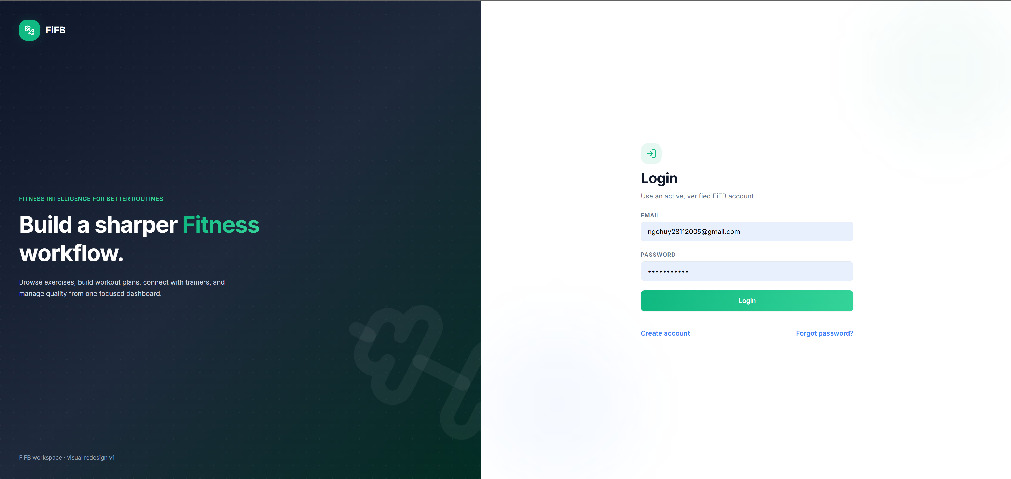
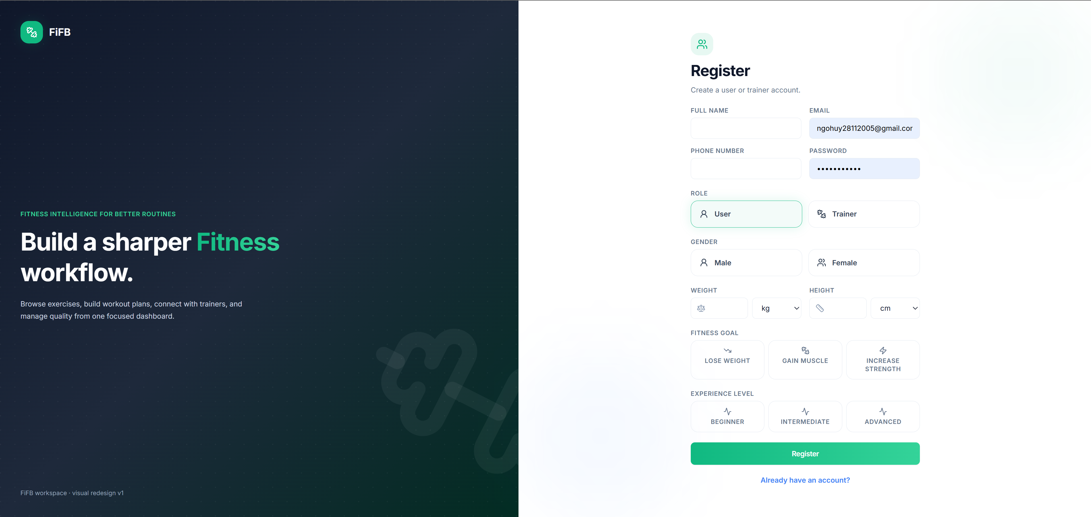
[Hình 5.1: Login and Registration Screens]
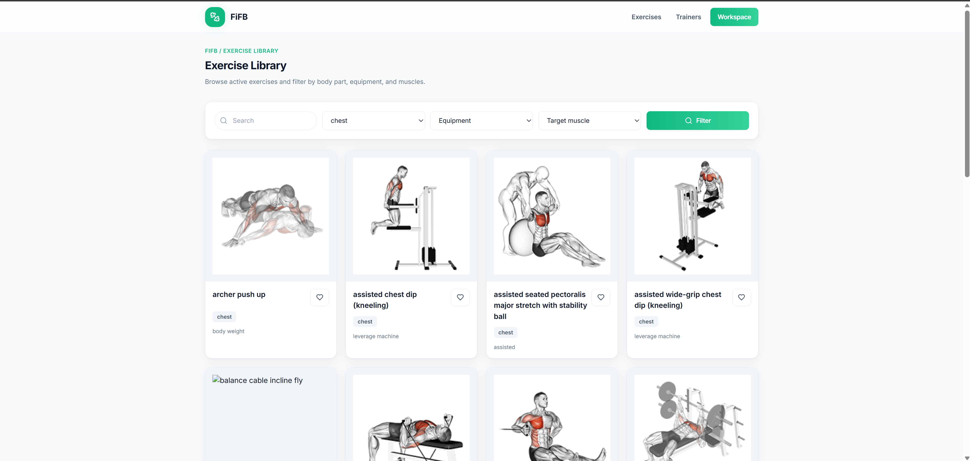
[Hình 5.2: User Exercise Library with Search and Filters]
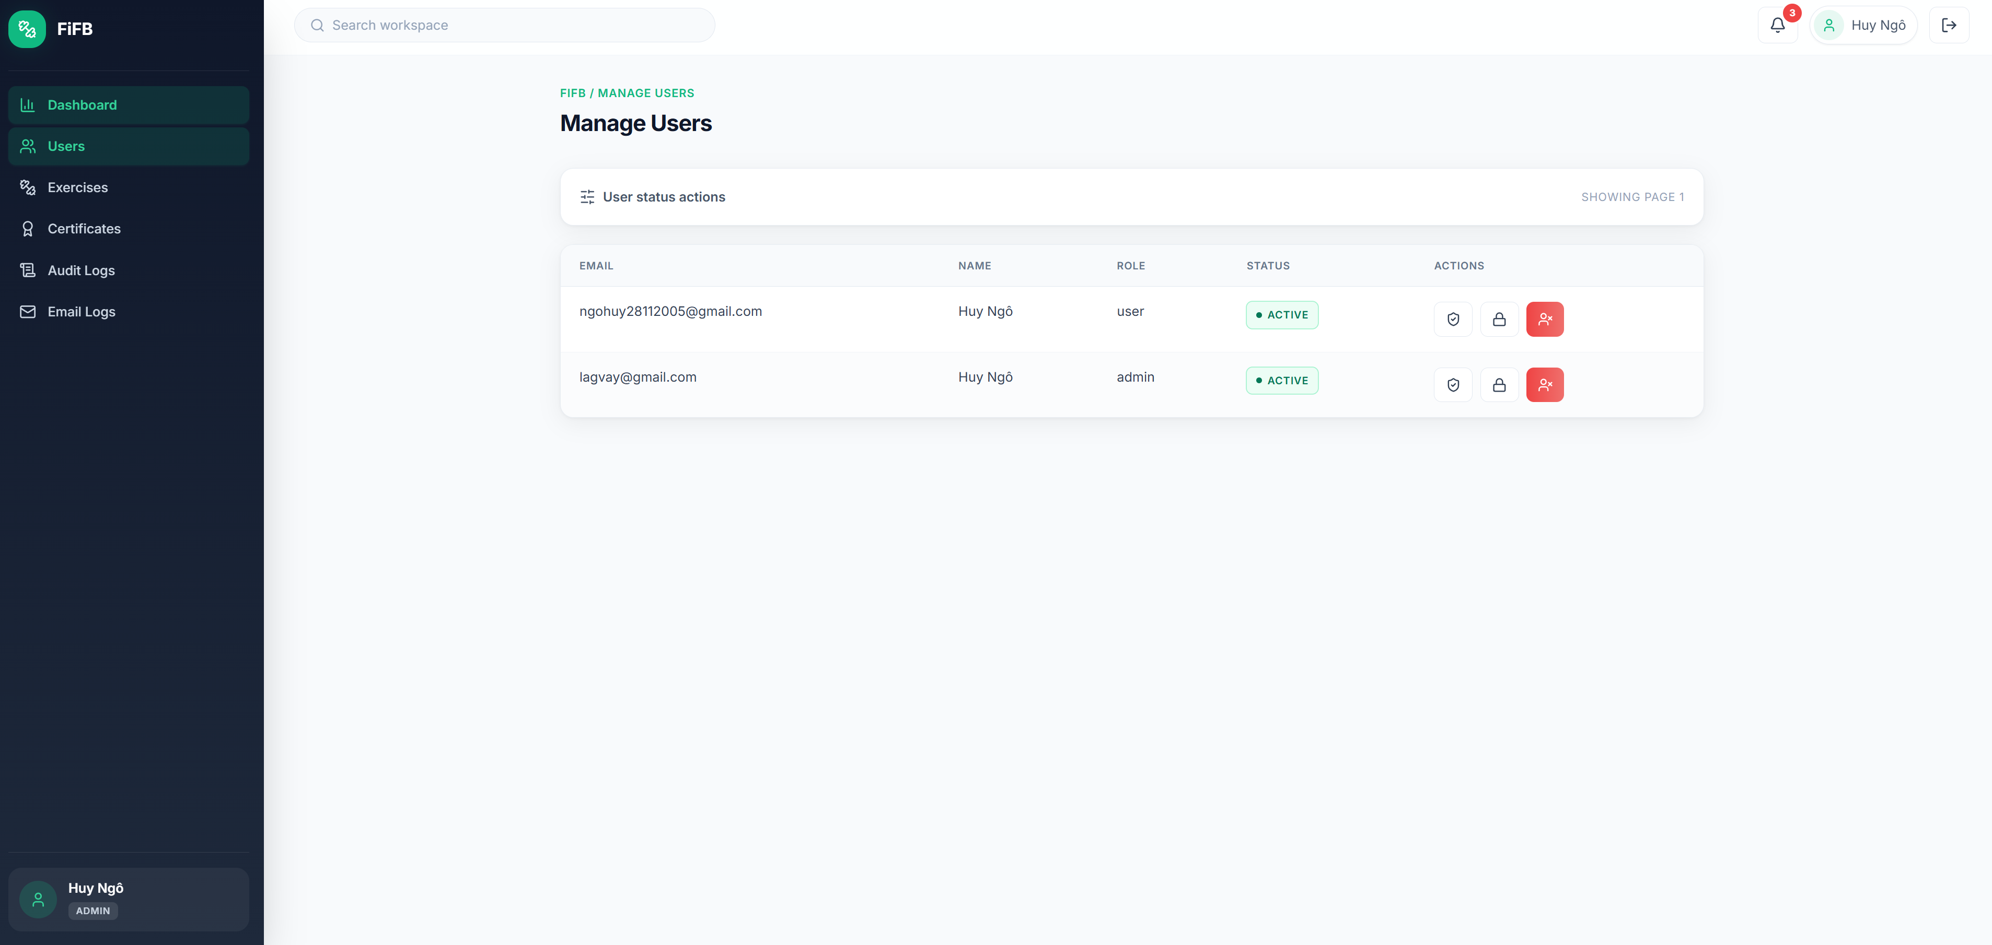
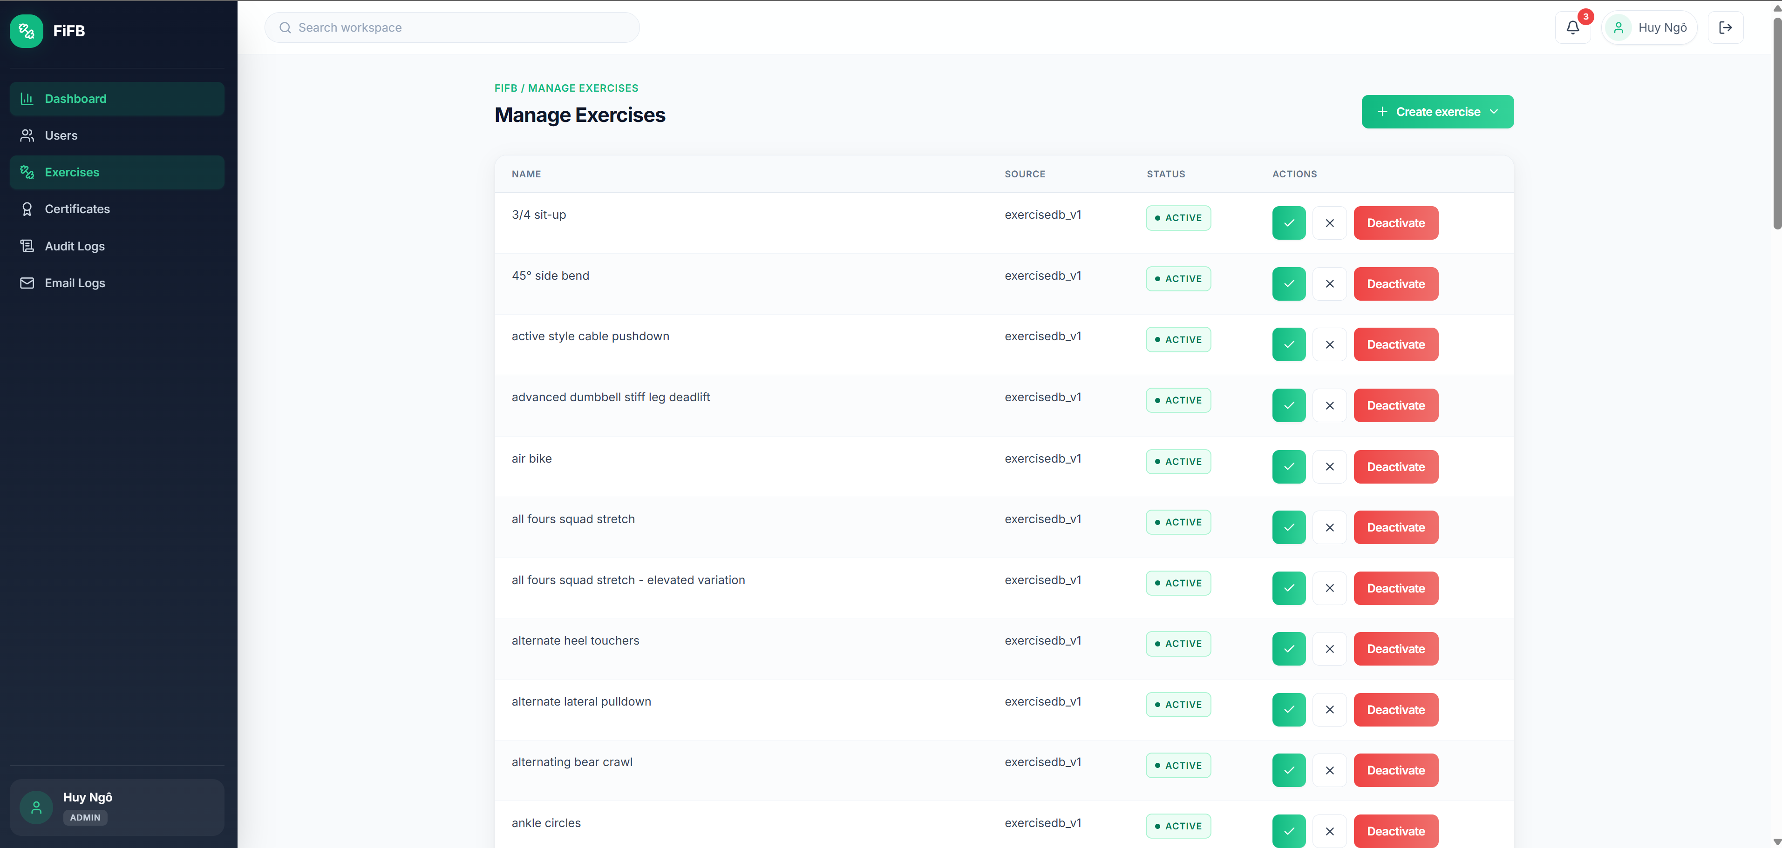
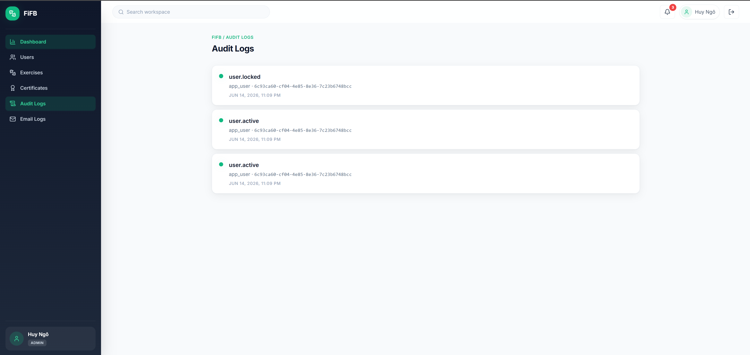
[Hình 5.3: Admin User and Exercise Management Screens. The repository also contains an audit-log screen, but it is not evaluated as a core GR1 requirement.]

5.3 Functional Evaluation

5.3.1 Authentication and Role Access
- Users can log in with email and password and receive an authenticated session.
- The backend token contains the account role and status, allowing middleware to reject unauthorized requests.
- The frontend redirects unauthenticated visitors to login and restricts User, Trainer, and Admin pages according to role.
- Passwords are stored as bcrypt hashes, and API request bodies are validated before use.

5.3.2 User Management
- Admin can retrieve a paginated and filtered user list.
- Admin can view account information and change status to active, locked, or disabled.
- Authenticated users can view and update their own basic profile fields.

5.3.3 Exercise and Equipment Management
- Admin exercise creation, update, review, rejection, and deactivation flows are implemented.
- Equipment categories are stored separately and connected to exercises through the `exercise_equipments` junction table.
- The current implementation supports listing and adding equipment taxonomy entries and changing exercise mappings, but it does not manage individual physical machines, maintenance status, location, or availability.

5.3.4 User Exercise Lookup
- Users can search exercises by keyword and combine filters for body part, equipment, target muscle, and secondary muscle.
- Only active exercises are returned to normal users, while the detail page displays the complete exercise instructions and taxonomy associations.
- Pagination prevents the full library from being loaded in one response and supports a practical browsing demo.

5.3.5 Scope Assessment
- The repository demonstrates the required platform foundation, three roles, database design, login, user management, exercise management, and User exercise lookup.
- Equipment management is satisfied only at the category/taxonomy level. A strict interpretation of “machine management” as physical gym-machine inventory is therefore only partially satisfied.
- Additional workout, trainer-connection, chat, notification, caching, and deployment modules are not counted when assessing GR1 completion.
- The modular structure is adequate for extending the incomplete machine-management scope in GR2.

5.4 Limitations
The focused evaluation identifies the following limitations:
- Equipment scope: the `equipments` table represents categories used by exercises, not individual gym machines with model, serial number, location, condition, or maintenance information.
- Incomplete equipment CRUD: the documented taxonomy API supports listing and creating equipment entries, but dedicated update, deactivate, and delete operations for equipment categories are not clearly exposed.
- Basic Trainer scope: the core report uses only Trainer profile and exercise submission; broader certificate, connection, review, and chat functions are outside the assignment scope.
- Diagram scope mismatch: some existing figures were generated from the full repository and therefore show extension use cases or tables that are intentionally excluded from the focused evaluation.
- Testing depth: unit tests exist, but complete end-to-end tests for every User, Trainer, and Admin flow have not been demonstrated in this report.
- External exercise data: imported records depend on the quality and availability of the ExerciseDB source and may require manual review by Admin.

5.5 Development Plan for GR2
The next phase should first close the remaining gaps in the foundation before emphasizing advanced features:
Feature | Description
Physical Machine Management | Add a dedicated machine table with machine code, name/model, equipment category, gym location, operational status, purchase date, and maintenance information.
Full Equipment CRUD | Add update, deactivate, and delete rules for equipment categories with checks that protect existing exercise relationships.
Trainer Workflow Refinement | Clarify the Trainer dashboard and exercise-submission lifecycle without making trainer–client marketplace functions mandatory.
Focused Diagrams | Create a new use-case diagram and a core ERD that show only User, Trainer, Admin, users, exercises, equipment, and taxonomy relationships.
Comprehensive Testing | Add integration and end-to-end tests for login, role restrictions, user status changes, exercise CRUD, equipment management, and User search/filter flows.
Responsive UI | Systematically test and improve the core pages on mobile and tablet screen sizes.
Vietnamese Interface | Add Vietnamese labels and messages so the demo is easier to use in the target context.
Optional Extensions | Only after the foundation is accepted, selectively reintroduce workout tracking, trainer connections, chat, notifications, or AI features as GR2 extensions.

References
- Express.js Documentation. (n.d.). Retrieved from https://expressjs.com/
- React Documentation. (n.d.). Retrieved from https://react.dev/
- PostgreSQL Documentation. (n.d.). Retrieved from https://www.postgresql.org/docs/
- Vite Documentation. (n.d.). Retrieved from https://vitejs.dev/
- Tailwind CSS Documentation. (n.d.). Retrieved from https://tailwindcss.com/docs
- JSON Web Tokens (JWT) - RFC 7519. (2015). Retrieved from https://datatracker.ietf.org/doc/html/rfc7519
- ExerciseDB API. (n.d.). Retrieved from https://exercisedb.io/
- Zod Documentation. (n.d.). Retrieved from https://zod.dev/
- Axios Documentation. (n.d.). Retrieved from https://axios-http.com/docs/intro
- React Router Documentation. (n.d.). Retrieved from https://reactrouter.com/
FiFB Project Repository. (2026). Graduation-Research-FiFB. GitHub: https://github.com/ngohuyhust/Graduation-Research-FiFB

Appendices
Appendix A: API Endpoint Reference
The complete API specification is documented in `Document/API.md`. For the focused GR1 scope, the relevant sections are:
- Authentication and token endpoints.
- User and role permissions.
- Trainer profile and exercise-submission endpoints.
- Exercise, taxonomy, and Admin management endpoints.
Appendix B: Database Schema
The complete SQL schema is available in:
- `Document/DatabaseSQL-v2.txt` — full schema; the report analyzes only the core user, trainer-profile, exercise, equipment, body-part, muscle, junction, and audit tables.
Appendix C: Focused Project Repository Structure
Graduation-Research-FiFB/
├── Document/
│ ├── API.md # API and role documentation
│ └── DatabaseSQL-v2.txt # Complete database schema
├── client/src/
│ ├── api/ # Core API clients
│ ├── pages/auth/ # Login and account pages
│ ├── pages/user/ # Exercise lookup and detail
│ ├── pages/trainer/ # Trainer profile and submission
│ ├── pages/admin/ # User, exercise, and taxonomy management
│ └── routes/ # Protected and role-based routing
└── server/src/
├── middlewares/ # Authentication, roles, validation, errors
├── modules/auth/ # Login and token logic
├── modules/users/ # User profile and Admin user management
├── modules/trainers/ # Basic Trainer functions
├── modules/exercises/ # Exercise query and management
├── modules/exerciseTaxonomy/ # Body parts, muscles, equipment
└── modules/admin/ # Admin review operations
Other modules remain in the repository as extensions but are outside the focused GR1 report scope.

